The Las Vegas Valley Chapter is inviting YOU! to the SW Region Conference.
Let’s meet up in Las Vegas! Visit with old friends and make new ones!

Join us April 8th and 9th at the Palace Station Casino
2411 West Sahara Ave, Las Vegas, NV 89102

The Palace Station is conveniently located just off the strip.

There is a free shuttle from Las Vegas McCarran/Harry Reid Airport. It runs at 6:30 am, 7:30 am, 8:30 am, 9:30 am, 11:30 am, 1:30 pm, 3:30 pm, 5:30 pm 7:30 pm, 9:30 pm, and 12:00 am. The airport pick-up location is at Terminal 1 on Level 0 between stalls 21 -23. There are also free shuttle runs to and from Fashion Show Mall and T-Mobile Arena. Taxi’s and uber/lift from the airport to Palace Station run from $15.00 to $30.00.

This will be a hybrid meeting. Those members who cannot attend in person are welcome to join us by zoom. The cost of registration is $25.00. This includes those attending by zoom. The packet will only be sent to those members in good standing (paid up membership). The Zoom login and information will be sent out via email before the meeting.

The cost of the motel rooms is $164.28 per night, $328.76 for both nights. The number to make reservations is 800-634-3101; the Group Code is PCIGSWA. Please remember to tell them you are a member of the Gold Star Wives and to give them the code. There are a limited number of rooms at this rate so register early!! Cutoff date is March 2, 2022, for hotel reservations

There will be a catered, sit-down, dinner on Saturday night. The cost is $65.00 The choices are:

Sauteed Chicken Piccata, Sirloin Au Poivre with Port Wine Demi, and Risotto with Roasted Vegetables

We are creating T-shirts and coffee mugs to sell. More information on design will be coming out soon. T-shirts will be $15.00; coffee mugs will be $10.00. There will also be a raffle.

There will be a no-host dinner on Friday evening. Details will be provided shortly.

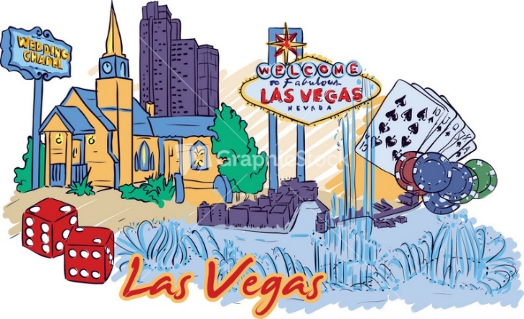
Come join us!!

Gold Star Wives of America Southwest Region
74th Annual Southwest Region Conference
April 8th & 9th, 2022
Palace Station Casino
2411 West Sahara Ave
Las Vegas, NV 89102
Hotel Reservation: 800-634-3101; Group Code: PCIGSWA
Room rate is $164.28 per night, $328.76. Rates available April 8th and 9th.
Cutoff date is March 2, 2022, for hotel reservations

Name_______________________________________________________________________
Address______________________________________________________________________
City, State, Zip________________________________________________________________
Telephone #_________________________________Email_____________________________
Emergency Contact____________________________________________________________
Member at large. Yes_____ or Chapter ______________________________ Veteran Y or N
Officer Position held _________________________ First time attending__________________
Name of Guest_________________________ Relationship ____________________________
Children Names ___________________ Ages _____________
Banquet dinner meal selection, select one for each person,
Member: Chicken Piccata __ Sirloin with Port Wine Demi __ Risotto with Roasted Vegetable __
Guest: Chicken Piccata __ Sirloin with Port Wine Demi __ Risotto with Roasted Vegetable __
T-Shirt $15.00 ___ Select Size Small Med Large X-Large XX-Large Coffee Mug $10.00 ____
Conference Registration Deadline - Must be received by March 15th
Register online or by mail
Mail completed form and check for registration and guests to:
Olive Bouault, Southwest Region Treasurer, 5000 Morning Splash Ave, Las Vegas, NV 89131
Make Check payable to Gold Star Wives of America, Inc. Southwest Region
Registration packet $25.00; Banquet $65.00; Guest banquet $65.00;
T-shirt $15.00 Coffee mug $10.00
Total ________________
Spouse’s Full Name ______________________________________________

