Capitol View Chapter on the Move

December Actives

2016 Parents & Children Fighting Cancer Holiday Party
Andrews AFB
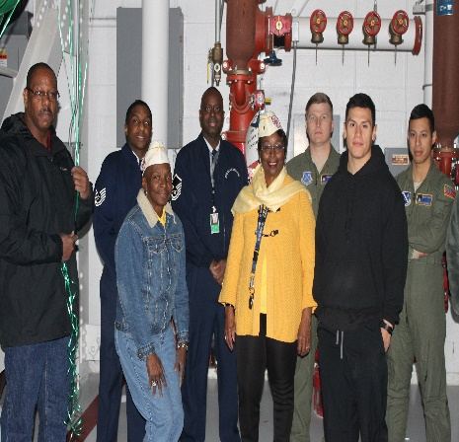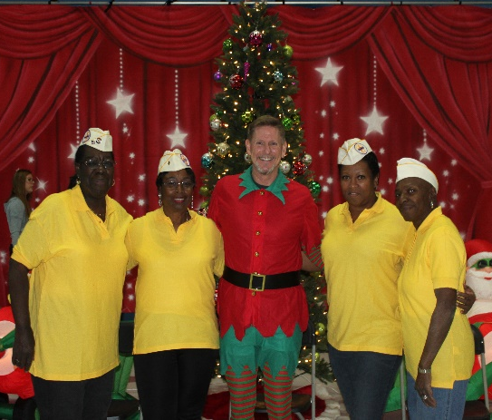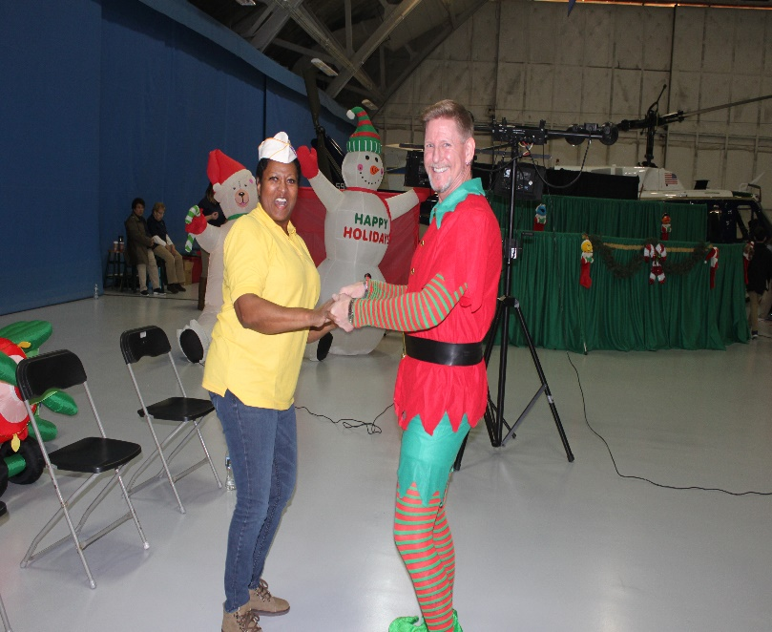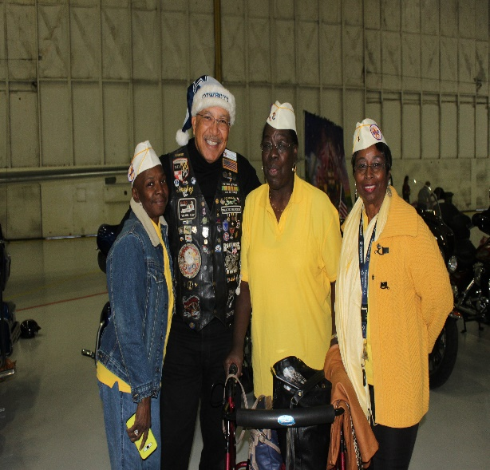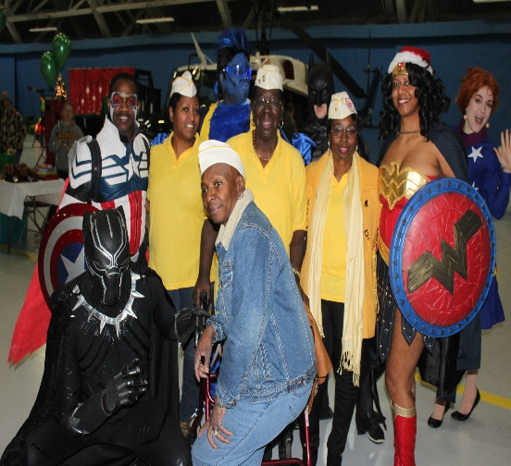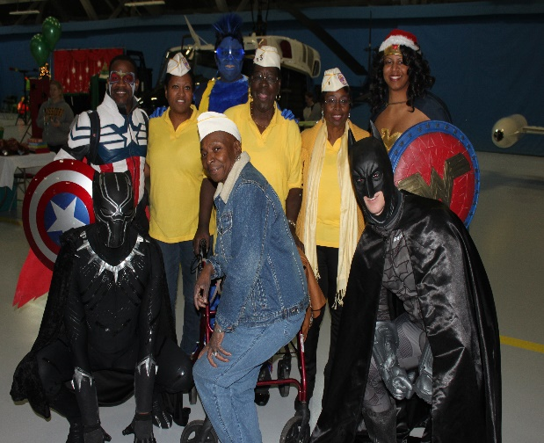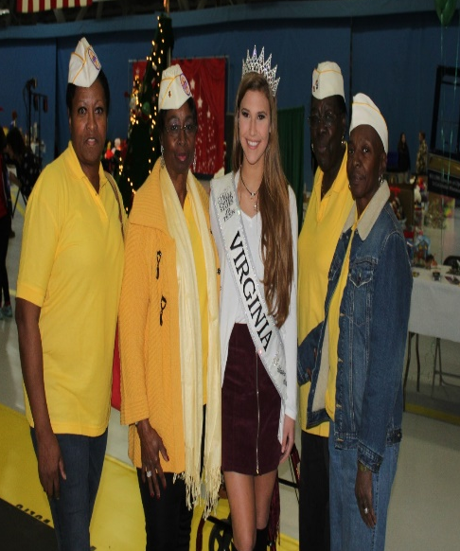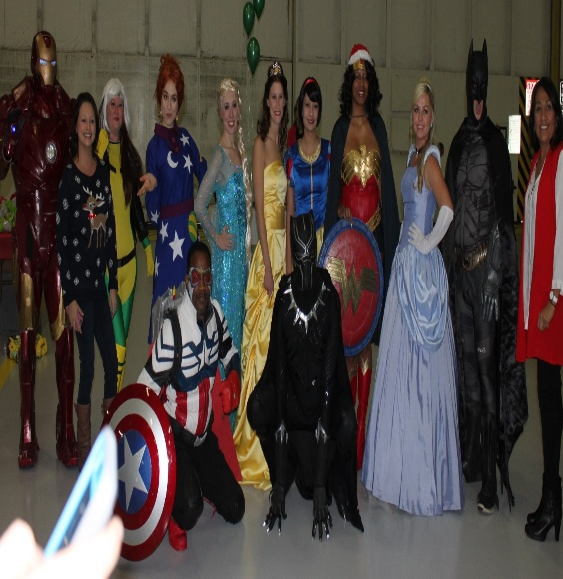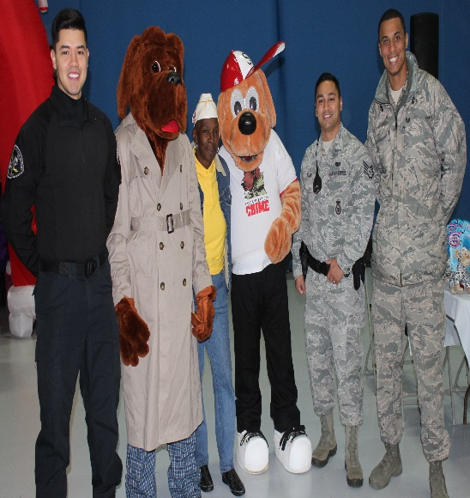
December 10, 2016: Capitol View Chapter volunteer for the- 2016 Parents & Children Fighting Cancer Holiday Party at Andrew AFB,
Hangar 3, Sponsored by the Fisher House. Members dress comfortable with yellow tops with our official Cap. Members assisted with decorating, serving, entertaining the Parents and Children. The members got the opportunity to dance with Santa, and his Elf’s, while others members posed with Miss Virginia and partied with Cartoon Characters. (no photo of Children due to Privacy Act)

